What’s a Vector?
A vector is a mathematical object possessing, and fully described by, a magnitude and a direction. It’s possible to talk about vectors simply in terms of numbers, but it’s often a lot easier to represent them graphically as arrows. The vector’s magnitude is equal to the length of the arrow, and its direction corresponds to where the arrow is pointing. Physicists commonly refer to the point of a vector as its tip and the base as its tail.
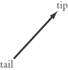
There are a number of ways to label vectors. You may have seen vectors labeled or A. This book will follow the convention you’ll find on SAT II Physics: vectors are written in boldface and vector magnitudes in plain script. For example, vector A has magnitude A.
Vectors vs. Scalars
In contrast to a vector quantity, a scalar quantity does not have a direction; it is fully described by just a magnitude. Examples of scalar quantities include the number of words in this sentence and the mass of the Hubble Space Telescope. Vector quantities you’ll likely come across quite frequently in physics include displacement, s; velocity, v; acceleration, a; force, F; momentum, p; electric field, E; and magnetic field, B.
When in doubt, ask yourself if a certain quantity comes with a direction. If it does, it’s a vector. If it doesn’t, it’s a scalar.
EXAMPLE
 | Which of the following sentences deal with vector quantities?
I. “I used to drive a 10-ton truck.”
II. “You’ll find a gas station if you follow this road 20 miles due north.”
III. “The 10-volt battery is the one on your left.”
 | (A) | I only
 | (B) | II only
 | (C) | III only
 | (D) | II and III
 | (E) | I, II, and III

“I used to drive a 10-ton truck” deals with mass, which is a scalar quantity. When we know that a truck weighs 10 tons, we don’t need to ask, “in what direction?” “You’ll find a gas station if you follow this road 20 miles due north” deals with the vector quantity of displacement. When asking directions to a gas station, you don’t simply want to know how far it is from where you are, but also in what direction you need to go. “The 10-volt battery is the one on your left” is slightly tricky: volts are a scalar quantity—you don’t ask in what direction the battery’s volts are going. However, you might be deceived by the mention of “on your left.” However, “on your left” is a reference to the battery, not to the volts. The magnitude “10 volts” doesn’t have a direction, so that quantity is a scalar. The answer is B.

Vector Addition
There are bound to be several questions on SAT II Physics that involve vector addition, particularly in mechanics. The test doesn’t demand a very sophisticated understanding of vector addition, but it’s important that you grasp the principle. That is, you won’t be asked to make complicated calculations, but you will be expected to know what happens when you add two vectors together.
The easiest way to learn how vector addition works is to look at it graphically. There are two equivalent ways to add vectors graphically: the tip-to-tail method and the parallelogram method. Both will get you to the same result, but one or the other is more convenient depending on the circumstances.
Tip-to-Tail Method
We can add any two vectors, A and B, by placing the tail of B so that it meets the tip of A. The sum, A + B, is the vector from the tail of A to the tip of B.
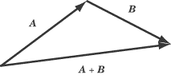
Note that you’ll get the same vector if you place the tip of B against the tail of A. In other words, A + B and B + A are equivalent.
Parallelogram Method
To add A and B using the parallelogram method, place the tail of B so that it meets the tail of A. Take these two vectors to be the first two adjacent sides of a parallelogram, and draw in the remaining two sides. The vector sum, A + B, extends from the tails of A and B across the diagonal to the opposite corner of the parallelogram. If the vectors are perpendicular and unequal in magnitude, the parallelogram will be a rectangle. If the vectors are perpendicular and equal in magnitude, the parallelogram will be a square.
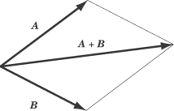
Adding Vector Magnitudes
Of course, knowing what the sum of two vectors looks like is often not enough. Sometimes you’ll need to know the magnitude of the resultant vector. This, of course, depends not only on the magnitude of the two vectors you’re adding, but also on the angle between the two vectors.
Adding Perpendicular Vectors
Suppose vector A has a magnitude of 8, and vector B is perpendicular to A with a magnitude of 6. What is the magnitude of A + B? Since vectors A and B are perpendicular, the triangle formed by A, B, and A + B is a right triangle. We can use the Pythagorean Theorem to calculate the magnitude of A + B, which is
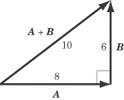
Adding Parallel Vectors
If the vectors you want to add are in the same direction, they can be added using simple arithmetic. For example, if you get in your car and drive eight miles east, stop for a break, and then drive six miles east, you will be 8 + 6 = 14 miles east of your origin. If you drive eight miles east and then six miles west, you will end up 8 – 6 = 2miles east of your origin.
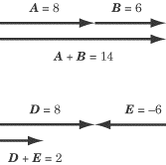
Adding Vectors at Other Angles
When A and B are neither perpendicular nor parallel, it is more difficult to calculate the magnitude of A + B because we can no longer use the Pythagorean Theorem. It is possible to calculate this sum using trigonometry, but SAT II Physics will never ask you to do this. For the most part, SAT II Physics will want you to show graphically what the sum will look like, following the tip-to-tail or parallelogram methods. On the rare occasions that you need to calculate the sum of vectors that are not perpendicular, you will be able to use the component method of vector addition, explained later in this chapter.
EXAMPLE
Vector A has a magnitude of 9 and points due north, vector B has a magnitude of 3 and points due north, and vector C has a magnitude of 5 and points due west. What is the magnitude of the resultant vector, A + B + C?

First, add the two parallel vectors, A and B. Because they are parallel, this is a simple matter of straightforward addition: 9 + 3 = 12. So the vector A + B has a magnitude of 12 and points due north. Next, add A + B to C. These two vectors are perpendicular, so apply the Pythagorean Theorem:
The sum of the three vectors has a magnitude of 13. Though a little more time-consuming, adding three vectors is just as simple as adding two.

Vector Subtraction
---You probably know that subtraction is the same thing as adding a negative: 8 – 5 is the same thing as 8 + (–5). The easiest way to think about vector subtraction is in terms of adding a negative vector. What’s a negative vector? It’s the same vector as its positive counterpart, only pointing in the opposite direction.
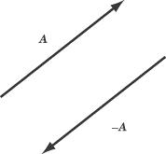
A – B, then, is the same thing as A + (–B). For instance, let’s take the two vectors Aand B:
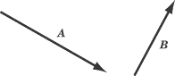
To subtract B from A, take a vector of the same magnitude as B, but pointing in the opposite direction, and add that vector to A, using either the tip-to-tail method or the parallelogram method.
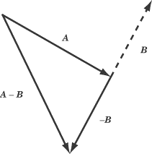

Multiplication by a Scalar
Multiplication is like repeated addition. Multiplying 4 by 3 means adding four three times: . The multiplication of a vector times a scalar works in the same way. Multiplying the vector A by the positive scalar c is equivalent to adding together c copies of the vector A. Thus 3A = A + A + A. Multiplying a vector by a scalar will get you a vector with the same direction, but different magnitude, as the original.
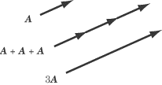
The result of multiplying A by c is a vector in the same direction as A, with a magnitude of . If c is negative, then the direction of A is reversed by scalar multiplication.

Vector Components
As we have seen, vector addition and scalar multiplication can produce new vectors out of old ones. For instance, we produce the vector A + B by adding the two vectors Aand B. Of course, there is nothing that makes A + B at all distinct as a vector from A or B: all three have magnitudes and directions. And just as A + B can be construed as the sum of two other vectors, so can A and B. In problems involving vector addition, it’s often convenient to break a vector down into two components, that is, two vectors whose sum is the vector in question.
Basis Vectors
We often graph vectors in an xy-coordinate system, where we can talk about vectors in purely numerical terms. For instance, the vector (3,4) is the vector whose tail is at the origin and whose tip is at the point (3,4) on the coordinate plane. From this coordinate, you can use the Pythagorean Theorem to calculate that the vector’s magnitude is 5 and trigonometry to calculate that its direction is about 53.1º above the x-axis.
Two vectors of particular note are (1,0), the vector of magnitude 1 that points along the x-axis, and (0,1), the vector of magnitude 1 that points along the y-axis. These are called the basis vectors and are written with the special hat notation: and respectively.
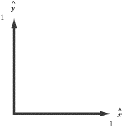
The basis vectors are important because you can express any vector in terms of the sum of multiples of the two basis vectors. For instance, the vector (3,4) that we discussed above—call it A—can be expressed as the vector sum .
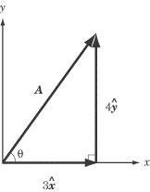
The vector is called the “x-component” of A and the is called the “y-component” of A. In this book, we will use subscripts to denote vector components. For example, the x-component of A is and the y-component of vector A is .
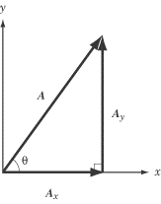
The direction of a vector can be expressed in terms of the angle by which it is rotated counterclockwise from the x-axis.
Vector Decomposition
The process of finding a vector’s components is known as “resolving,” “decomposing,” or “breaking down” a vector. Let’s take the example, illustrated above, of a vector, A, with a magnitude of A and a direction above the x-axis. Because , , and Aform a right triangle, we can use trigonometry to solve this problem. Applying the trigonometric definitions of cosine and sine,

we find:

Vector Addition Using Components
Vector decomposition is particularly useful when you’re called upon to add two vectors that are neither parallel nor perpendicular. In such a case, you will want to resolve one vector into components that run parallel and perpendicular to the other vector.
EXAMPLE
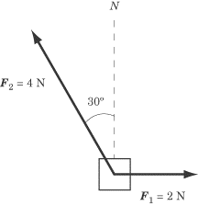
Two ropes are tied to a box on a frictionless surface. One rope pulls due east with a force of 2.0N. The second rope pulls with a force of 4.0N at an angle 30Âº west of north, as shown in the diagram. What is the total force acting on the box?

To solve this problem, we need to resolve the force on the second rope into its northward and westward components.
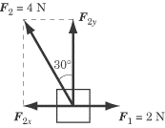
Because the force is directed 30º west of north, its northward component is
and its westward component is
Since the eastward component is also 2.0N, the eastward and westward components cancel one another out. The resultant force is directed due north, with a force of approximately 3.4N.
You can justify this answer by using the parallelogram method. If you fill out the half-completed parallelogram formed by the two vectors in the diagram above, you will find that the opposite corner of the parallelogram is directly above the corner made by the tails of those two vectors.
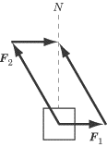
Vector Multiplication
There are two forms of vector multiplication: one results in a scalar, and one results in a vector.
Dot Product
The dot product, also called the scalar product, takes two vectors, “multiplies” them together, and produces a scalar. The smaller the angle between the two vectors, the greater their dot product will be. A common example of the dot product in action is the formula for work, which you will encounter in Chapter 4. Work is a scalar quantity, but it is measured by the magnitude of force and displacement, both vector quantities, and the degree to which the force and displacement are parallel to one another.
The dot product of any two vectors, A and B, is expressed by the equation: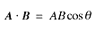
where is the angle made by A and B when they are placed tail to tail.
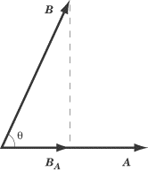
The dot product of A and B is the value you would get by multiplying the magnitude of A by the magnitude of the component of B that runs parallel to A. Looking at the figure above, you can get A · B by multiplying the magnitude of A by the magnitude of , which equals . You would get the same result if you multiplied the magnitude of B by the magnitude of , which equals .
Note that the dot product of two identical vectors is their magnitude squared, and that the dot product of two perpendicular vectors is zero.
EXAMPLE
Suppose the hands on a clock are vectors, where the hour hand has a length of 2 and the minute hand has a length of 4. What is the dot product of these two vectors when the clock reads 2 o’clock?

The angle between the hour hand and the minute hand at 2 o’clock is 60º. With this information, we can simply plug the numbers we have into the formula for the dot product:
The Cross Product
The cross product, also called the vector product, “multiplies” two vectors together to produce a third vector, which is perpendicular to both of the original vectors. The closer the angle between the two vectors is to the perpendicular, the greater the cross product will be. We encounter the cross product a great deal in our discussions of magnetic fields. Magnetic force acts perpendicular both to the magnetic field that produces the force, and to the charged particles experiencing the force.
The cross product can be a bit tricky, because you have to think in three dimensions. The cross product of two vectors, A and B, is defined by the equation: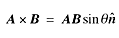
where is a unit vector perpendicular to both A and B. The magnitude of the cross product vector is equal to the area made by a parallelogram of A and B. In other words, the greater the area of the parallelogram, the longer the cross product vector.
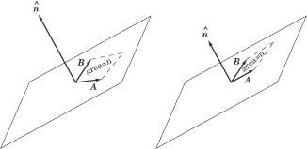
The Right-Hand Rule
You may have noticed an ambiguity here. The two vectors A and B always lie on a common plane and there are two directions perpendicular to this plane: “up” and “down.”
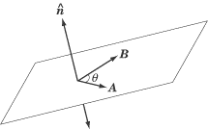
There is no real reason why we should choose the “up” or the “down” direction as the right one, but it’s important that we remain consistent. To that end, everybody follows the convention known as the right-hand rule. In order to find the cross product, : Place the two vectors so their tails are at the same point. Align your right hand along the first vector, A, such that the base of your palm is at the tail of the vector, and your fingertips are pointing toward the tip. Then curl your fingers via the small angle toward the second vector, B. If B is in a clockwise direction from A, you’ll find you have to flip your hand over to make this work. The direction in which your thumb is pointing is the direction of , and the direction of .
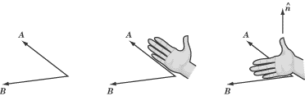
Note that you curl your fingers from A to B because the cross product is . If it were written , you would have to curl your fingers from B to A, and your thumb would point downward. The order in which you write the two terms of a cross product matters a great deal.
If you are right-handed, be careful! While you are working hard on SAT II Physics, you may be tempted to use your left hand instead of your right hand to calculate a cross product. Don’t do this.
EXAMPLE
Suppose once again that the minute hand of a clock is a vector of magnitude 4 and the hour hand is a vector of magnitude 2. If, at 5 o’clock, one were to take the cross product of the minute handthe hour hand, what would the resultant vector be?

First of all, let’s calculate the magnitude of the cross product vector. The angle between the hour hand and the minute hand is 150º: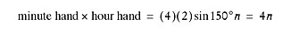
Using the right-hand rule, you’ll find that, by curling the fingers of your right hand from 12 o’clock toward 5 o’clock, your thumb points in toward the clock. So the resultant vector has a magnitude of 4 and points into the clock.

Key Formulas
Dot Product
Cross Product
Magnitude
Direction
X-, Y-Components
Vector Addition
Practice Questions
 | 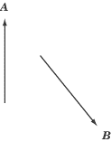
1. | Which of the following vectors best represents the vector A + B?
 | (A)
 | (B)
 | (C)
 | (D)
 | (E)

2. | Vector A has a magnitude of 5 in the leftward direction and B has a magnitude of 2 in the rightward direction. What is the value of 2A – B?
 | (A) | 12 in the leftward direction
 | (B) | 10 in the leftward direction
 | (C) | 8 in the leftward direction
 | (D) | 8 in the rightward direction
 | (E) | 12 in the rightward direction

3. | When the tail of vector A is set at the origin of the xy-axis, the tip of A reaches (3,6). When the tail of vector B is set at the origin of the xy-axis, the tip of Breaches (–1,5). If the tail of vector A – B were set at the origin of the xy-axis, what point would its tip touch?
 | (A) | (2,11)
 | (B) | (2,1)
 | (C) | (–2,7)
 | (D) | (4,1)
 | (E) | (4,11)

4. | A and B are vectors, and is the angle between them. What can you do to maximize A Â· B?
I. Maximize the magnitude of A
II. Maximize the magnitude of B
III. Set to 90Âº
 | (A) | None of the above
 | (B) | I only
 | (C) | III only
 | (D) | I and II only
 | (E) | I, II, and III

 | 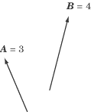
5. | Which of the following statements is NOT true about ?
 | (A) | It is a vector that points into the page
 | (B) | It has a magnitude that is less than or equal to 12
 | (C) | It has no component in the plane of the page
 | (D) | The angle it makes with B is less than the angle it makes with A
 | (E) | It is the same as –B A

Explanations
1. A
By adding A to B using the tip-to-tail method, we can see that (A) is the correct answer.
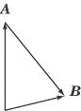
2. A
The vector 2A has a magnitude of 10 in the leftward direction. Subtracting B, a vector of magnitude 2 in the rightward direction, is the same as adding a vector of magnitude 2 in the leftward direction. The resultant vector, then, has a magnitude of 10 + 2 =12 in the leftward direction.
3. D
To subtract one vector from another, we can subtract each component individually. Subtracting the x-components of the two vectors, we get 3 –( –1) = 4, and subtracting the y-components of the two vectors, we get 6 – 5 = 1. The resultant vector therefore has an x-component of 4 and a y-component of 1, so that if its tail is at the origin of the xy-axis, its tip would be at (4,1).
4. D
The dot product of A and B is given by the formula A · B = AB cos . This increases as either A or B increases. However, cos = 0 when = 90°, so this is not a way to maximize the dot product. Rather, to maximize A · B one should set to 0º so cos = 1.
5. D
Let’s take a look at each answer choice in turn. Using the right-hand rule, we find that is indeed a vector that points into the page. We know that the magnitude of is , where is the angle between the two vectors. Since AB = 12, and since sin , we know that cannot possibly be greater than 12. As a cross product vector, is perpendicular to both A and B. This means that it has no component in the plane of the page. It also means that both A and B are at right angles with the cross product vector, so neither angle is greater than or less than the other. Last, is a vector of the same magnitude as , but it points in the opposite direction. By negating , we get a vector that is identical to .

